**Name**: Ravi Jamanbhai Makwana

**Roll No**: 21BCP418

Div-6, G-12

**Assignment-1**

1. whoami



1. pwd



1. ls



1. ls-R



1. ls -a

used to show hidden files



1. history

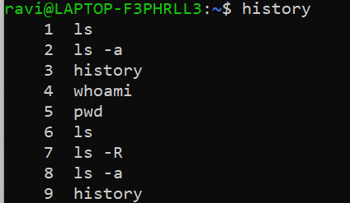

1. clear

clears terminal



1. echo

works like print

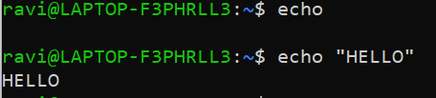

1. touch

used to create files



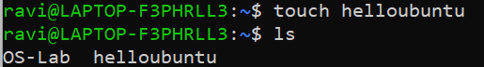

1. rm

used to remove files



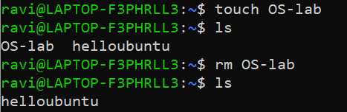

1. mkdir

used to create directories

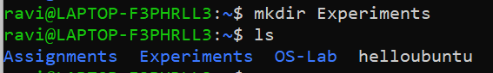

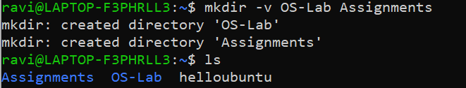

1. rmdir

used to remove directories

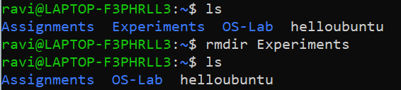

1. mv

used to rename (or move) files/directories

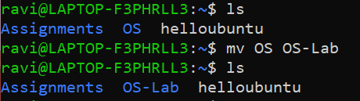

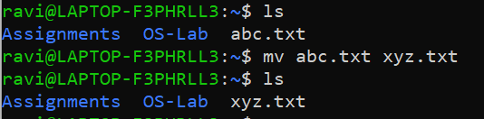

1. cd

change directory

cd .. is used to go back

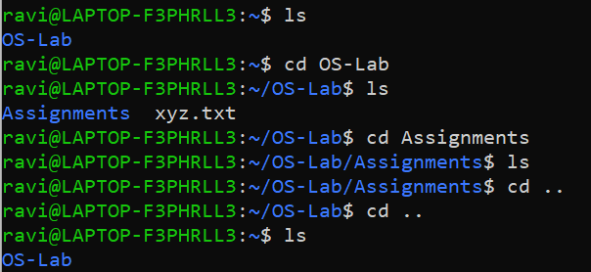

1. cmp

used to compare 2 files

returns nothing if they are identical, else returns the location or byte where they differ

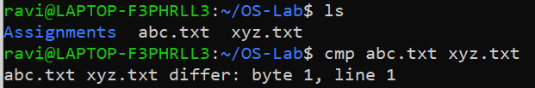

1. cat

used to view content of a file or concatenate and view contents of 2 files

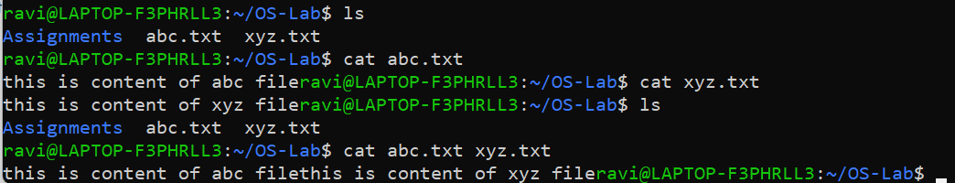

1. cal

calendar

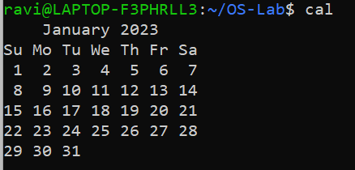

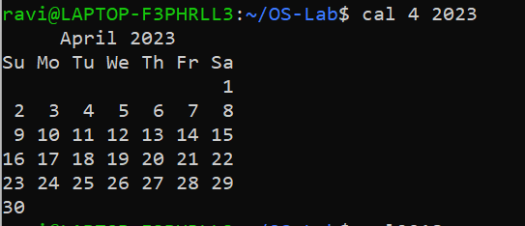

1. cal -y

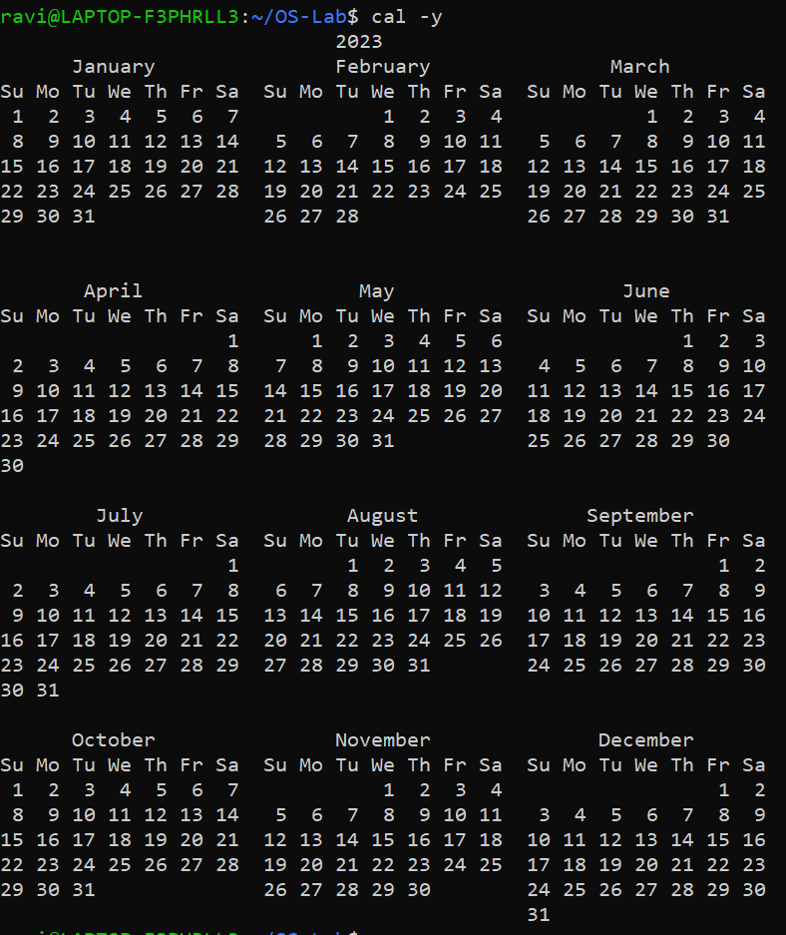

1. cal 2018

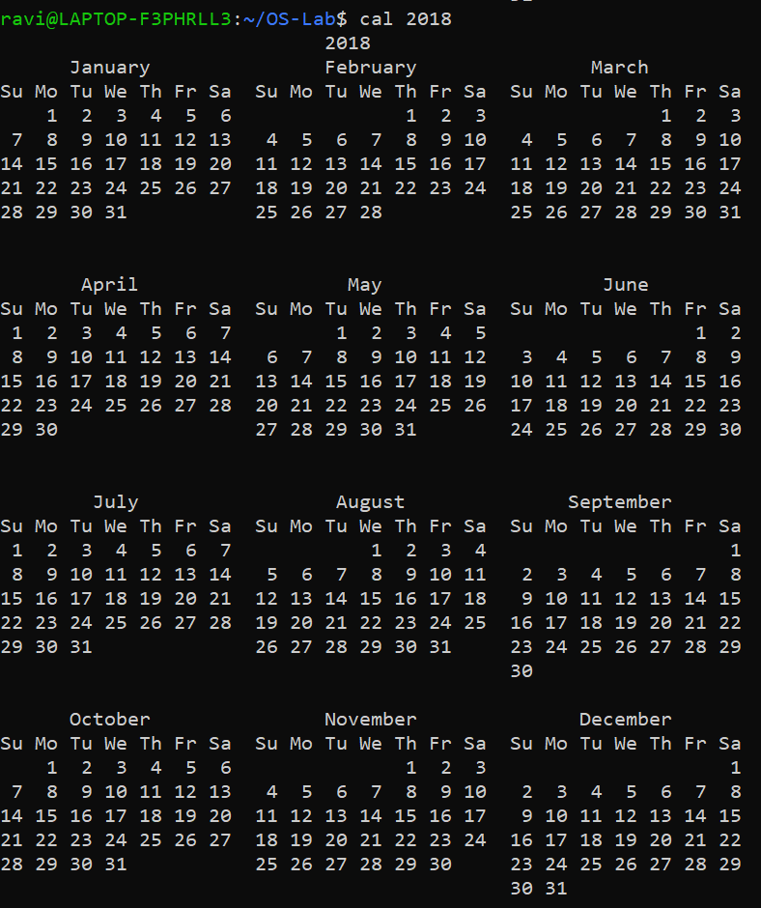

1. passwd

used to change password

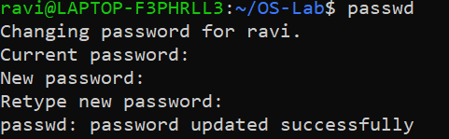

1. grep

used to search for specific words or expressions in any file

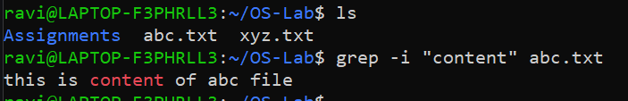

1. free

shows free spaces and buffers, etc.

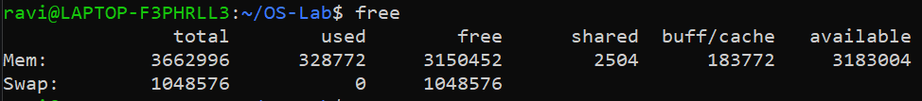

1. uname



1. uname -a



1. uname -s



1. uname -n



1. groups



1. comm

compares 2 sorted files and returns common lines and unique lines

output has 3 columns:

1st column has the unique lines that file1 contains

2nd column has the unique lines that file2 contains

3rd column has lines that are common to both files

Note: Both files HAS to be in sorted order before writing the command

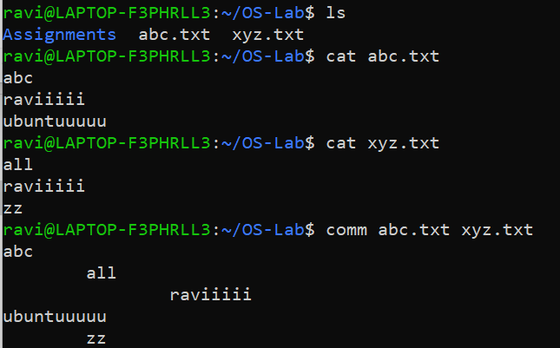

1. date



1. date -d

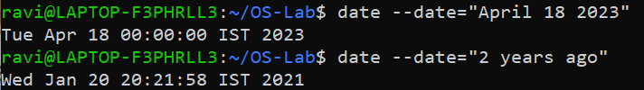

1. chmod

change mode

used to change access mode of a file

| **Access class** | **Operator** | **Access Type** |
| --- | --- | --- |
| u (user) | + (add access) | r (read) |
| g (group) | - (remove access) | w (write) |
| o (other) | = (set exact access) | x (execute) |
| a (all: u, g, and o) |  |  |

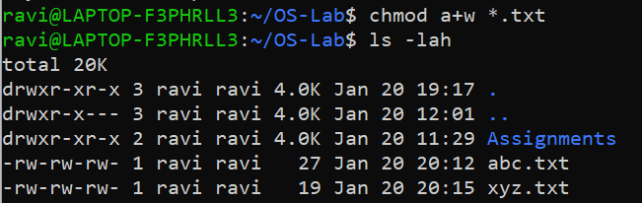

1. wc

word count

displays number of lines, words, characters in a file

